PMI® Project Management Salary Survey
Knowing your earning potential is an invaluable asset. Use it to leverage opportunities at work, invest in skills that increase your marketability and plan the next phase of your career.
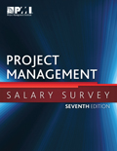
Awareness of project management salaries is critical for your organization as well, to compete for top talent as demand increases.

Get the salary survey
The PMI Project Management Salary Survey — Seventh Edition is available at the Marketplace. Click here to access the survey

PMI members have complimentary access
Members: log in to access the report and a self-directed query that lets you compare salary data by position and geographic location.

